Not
74hc04 hex inverter 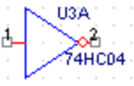v
74hc14 hex trigger schmitt inverter 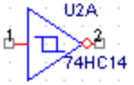
And
74hc08 quad 2-input 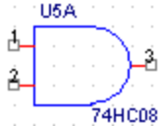
74hc11 triple 3-input
74hc21 dual 4-input

Nand
74hc00 quad 2-input 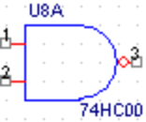
74hc10 3-input
74hc20 4-input
Or

74hc32 2-input 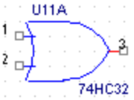
74hc4075 3-input
Nor

74hc02 2-input 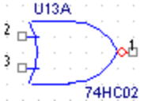
74hc27 3-input
74HC4002 4-input
Xor
74hc86 2-input 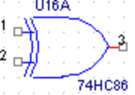
Equality
74hc7266 quad 2-input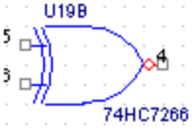
Decoders/Demultiplexers

74hc42 bcd to decimal decoder 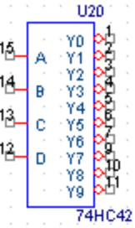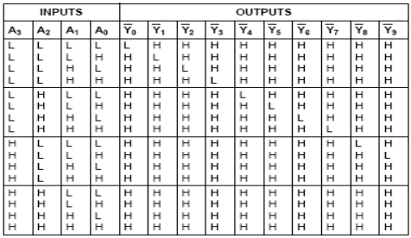

74hc137 3 to 8 decoder 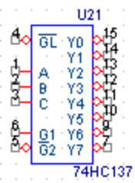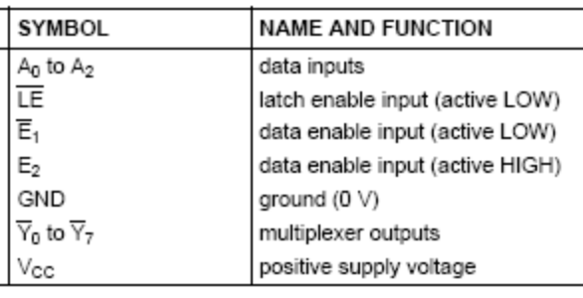
74hc139 dual 2 to 4 decoder/demultiplexer 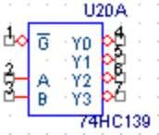
74hc154 4 to 16 line decoder/demultiplexer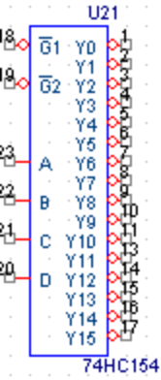
Encoder/Multiplexer

74hc148 8 to 3 line priority encoder 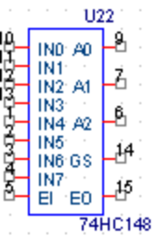
74hc153 dual 4 channel multiplexer 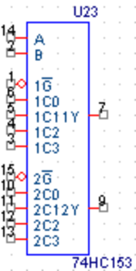 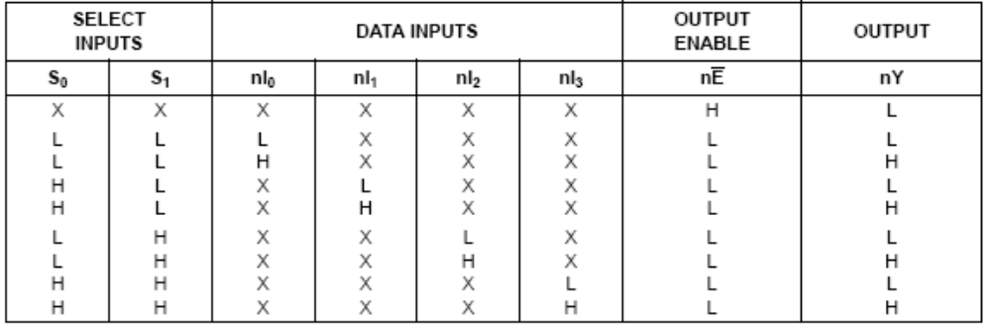

74hc157 quad 2 channel multiplexer 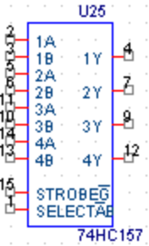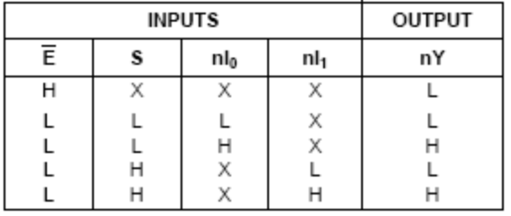
Special Function

74hc180 8-bit odd/even Parity generator/checker 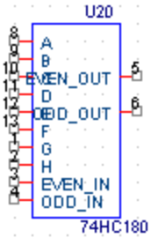
74hc283 4 bit binary full adder 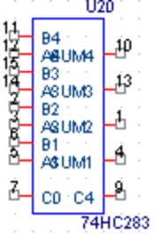
74hc688 8 bit equality comparator 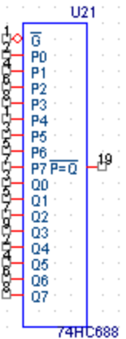
Flip Flops D

74hc74 dual d type flip flop whit preset and clear 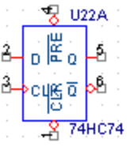 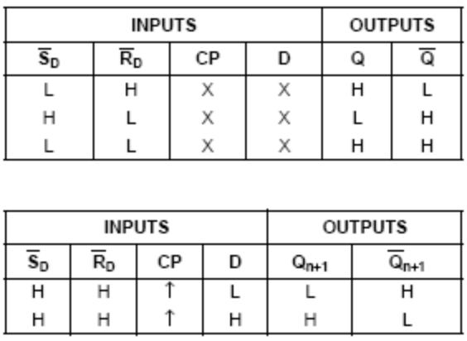

Flip Flops JK

74hc76 dual j-k flip flop whit preset and clear 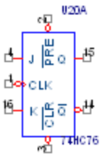 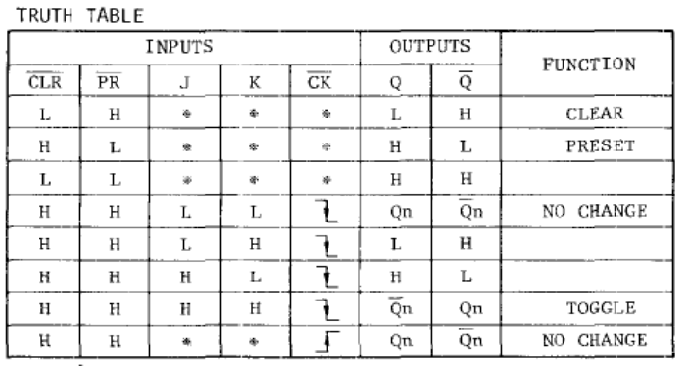

Shift Registers

74hc194 4 bit pipo (universal) shift register 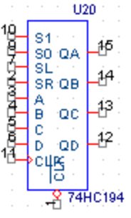 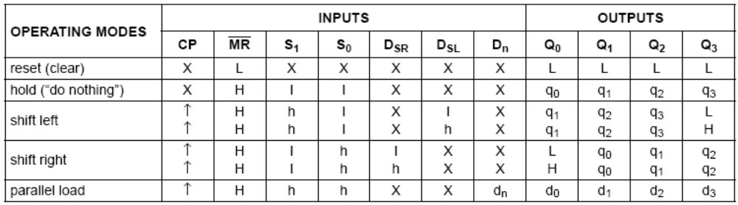

Synchronouse Counter

74hc160 sybchronouse bcd presetable 4-bit counter asyn reset 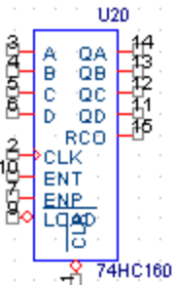 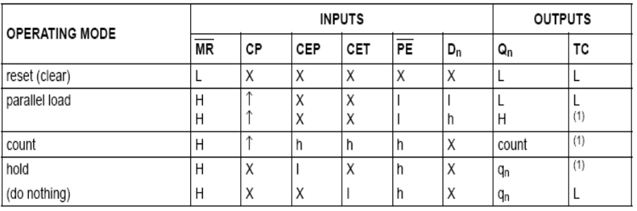
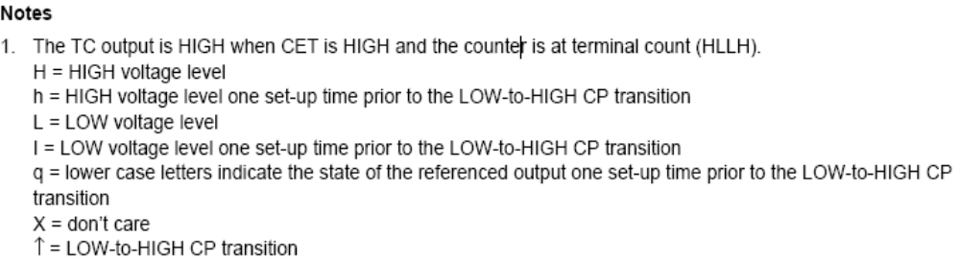

74hc161 sybchronouse binary presetable 4-bit counter asyn reset 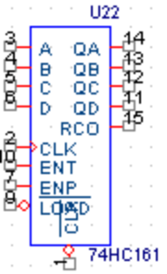

74hc190 4 bit bcd synchronous up/down counters 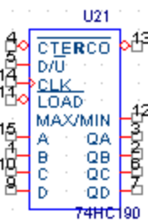 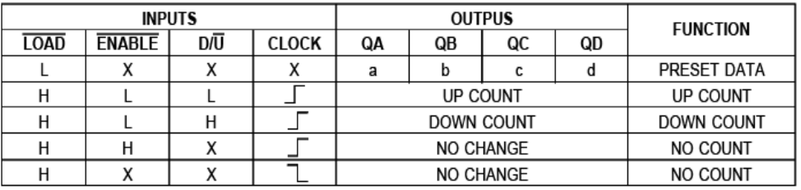

74hc191 4 bit binary synchronous up/down counters